Experiment No.: 6
Title: Use string functions and regex for email validation, data extraction, and text analysis.
Software/Tools Required: HTML5, CSS3, JavaScript, VS Code, Google Chrome
Theory: JavaScript provides string functions such as toLowerCase(), includes(), substring(), and replace() for text processing. Regular expressions (Regex) are used to search, extract, and validate text patterns, such as checking whether an email has a valid format.
Output:
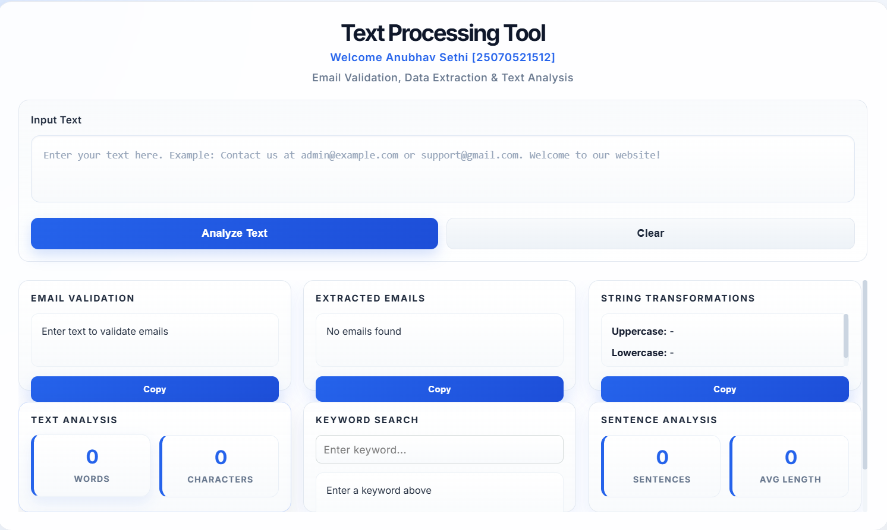

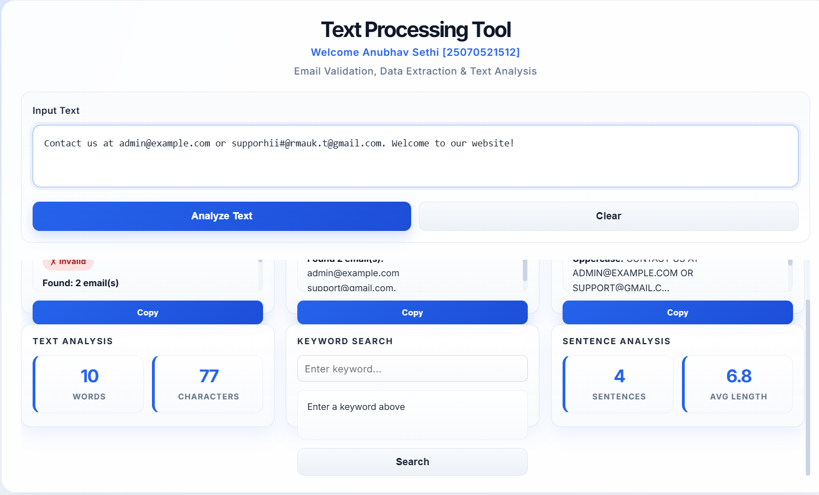
Result: Email validation, data extraction, and text analysis were successfully performed using JavaScript string methods and regular expressions..
Conclusion: String functions and Regex provide an efficient way to process, validate, search, and extract text data in JavaScript.

